**Entrepreneurship and Innovation**

**Assignment 1**

**Submit business idea summary in 50-100 words:**

**• What is the product/service?**

**• What does it do?**

**• Who are the customers? How many?**

**• How do you believe you will get paid?**

**• Why is this better than the currently available product/services?**

**You can use a mind map to describe your idea instead of only text.**

**Summary:**

The Business idea I have is of creating a Handy UV Box which can disinfect all the regular handy stuff which we regularly take with us when we go out and there is a chance of getting it infected by different types of viruses specially during the times of Corona virus which has significant chance of getting it and cleaning each and everything could be very time consuming and tedious, So by this product it can save a lot of time going through cleaning everything and hence easier the work. It will disinfect all the stuffs in it from all kind of viruses.

The Potential Customers are the office workers, essential workers, doctors, generally all of the people who have to go out for work and other stuffs. The estimated count could be millions of people. We believe it to be a great successful product and can get paid by companies, organization or sometimes self employed people who will pay you for sharing your ideas with them. (now you would be thinking Why they would want to pay you is obvious. You give them a great idea, they make money, and they will reward YOU in cash).Our product is new and has a different innovative idea, and no such product is available in market and if it is then it is not popular and we can take it to higher level and too more people by marketing and ads.

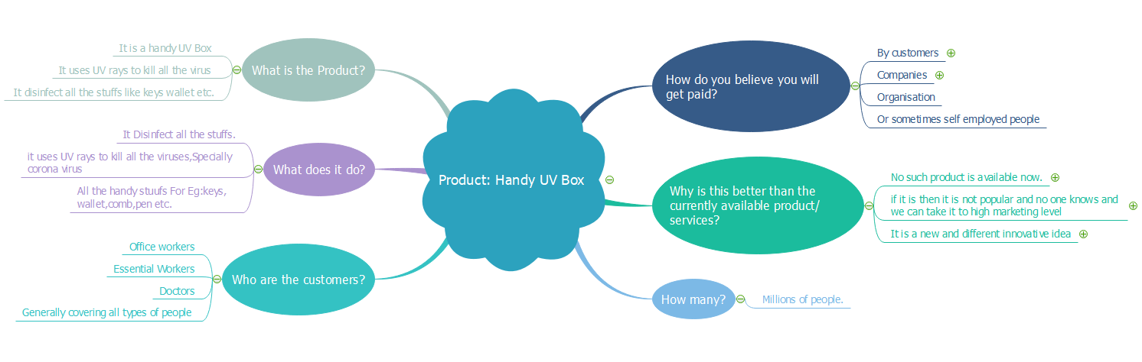

**Mind Map Of Handy UV Box**